Lesson 7 Demo 4
Docker Compose Setup
Objective: How to use Docker Compose to manage a container

Tools required: Docker Configuration

Pre-requisites: Ubuntu Configuration, Docker

Steps to be followed:
- Setting up docker-compose
- Creating a docker-compose file

Step 1: Setting up docker-compose
1.1 Install docker-compose using the command given below:
mkdir compose-test
cd compose-test
pip --version

1.2 Then type the command given below, to install docker-compose
sudo pip install docker-compose
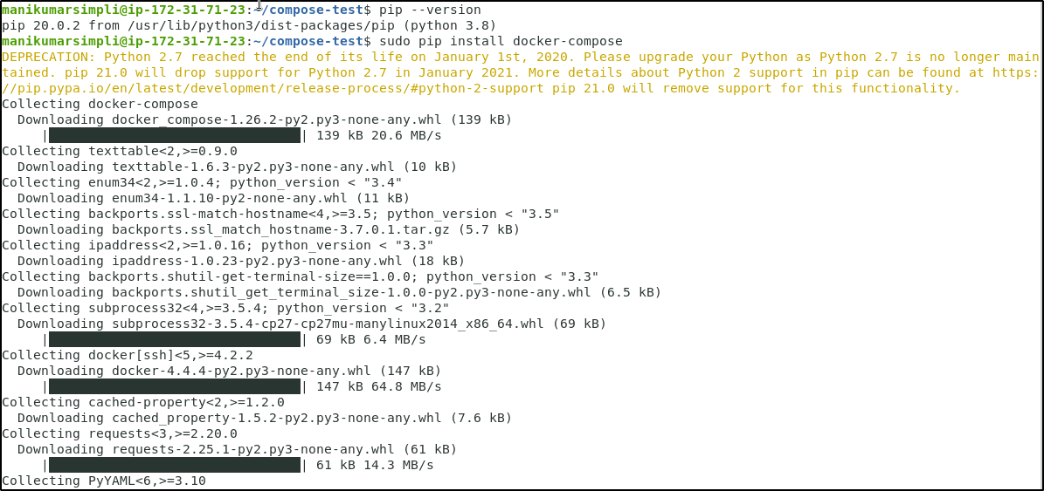
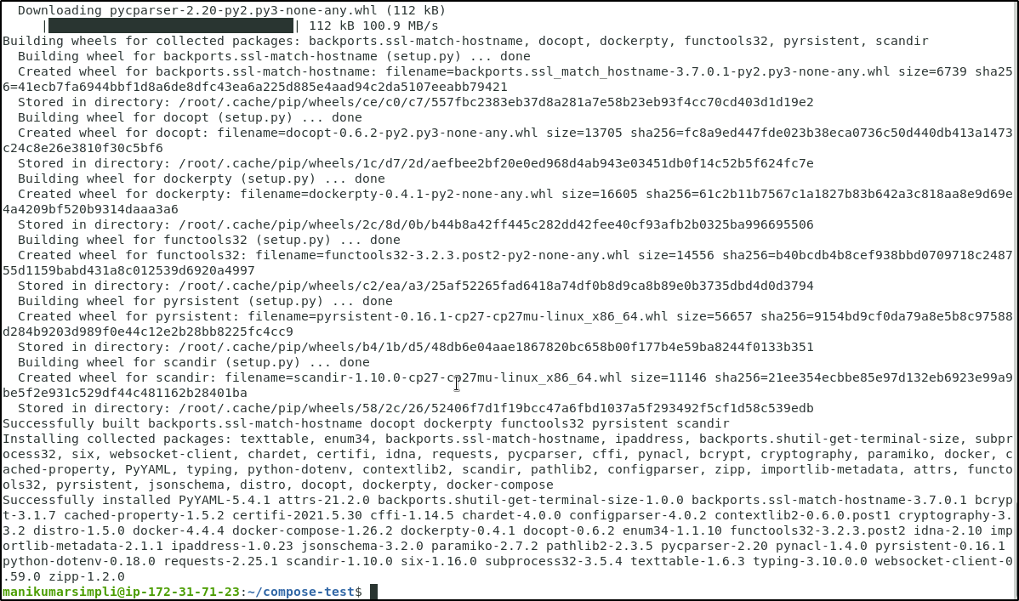

Step 2: Creating docker-compose file
2.1 Inside compose-test folder, create docker-compose.yml file, and add the following code in it:
vi docker-compose.yml

2.2 Add the following code snippet in the file:
version: '2'
services:
compose-test:
image: centos
links:
- compose-db
command: /usr/bin/curl compose-db:6379
compose-db:
image: redis
expose:
- "6379"
Note: After writing the above code in the yml file, press ESC button and enter “:wq” to save the file and exit the editor.
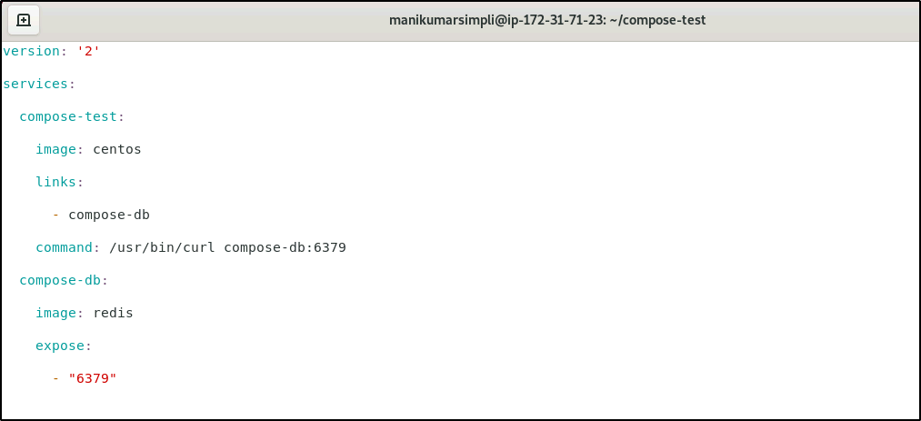

2.3 Run the following command to execute the yaml file:
sudo docker-compose up
